**ASSIGNMENT 2**

Jiaxin Tang

**FINANCIAL ECONOMETRICS | SUMMER 2023**

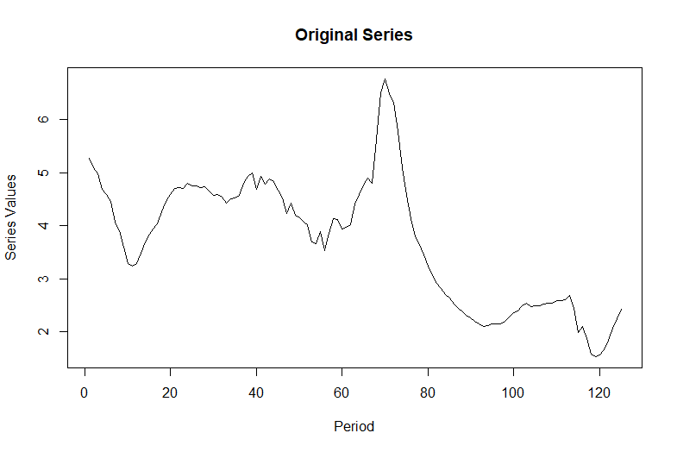

Paste the **level** series chart here

CREDIT CARD

DELINQUENCIES

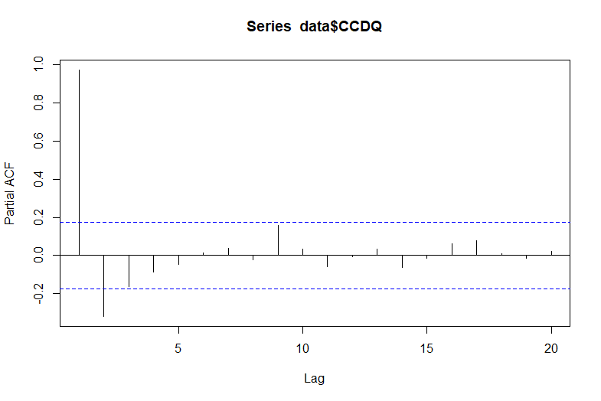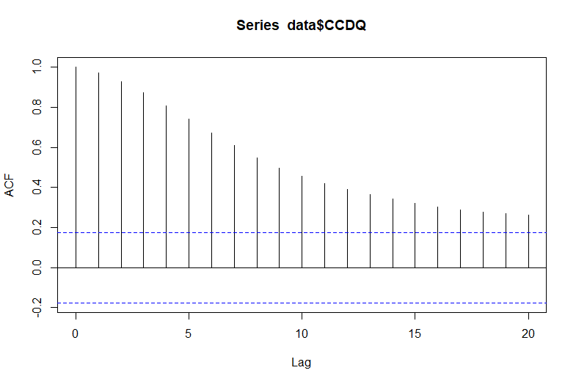

Paste the **ADF** test outputs for the **level** series here

In this and the next box paste the **ACF and PACF** for the **level** series

**OTHER OBSERVATIONS**

The ADF test and the autocorrelation graphs produce a consistent result: the level series is non-stationary. The p-value of the ADF test is very high, indicating that there are few stationary characteristics. Then the level series is not suitable with ARIMA without differencing.

Since there are no spikes, the seasonal component should not dominate, so the best approach is Holt’s exponential smoothing.

The ACF graph shows a gradual declining autocorrelations, which is consistent with the ADF test as non-stationary. There are no explicit spikes in the ACF graph.

The PACF graph shows almost no significant direct autocorrelations between lagged variables beyond the first, which also illustrates that variables with larger lags are hard to predict based on partial autocorrelations.

The level series chart is generally smooth, so there tends to be high positive autocorrelation between lagged terms. There may be a constant mean around 4 initially, but it deviates from the value later.

No explicit trend or seasonal patterns.

Therefore, tests are needed to identify the pattern.

**LEVEL SERIES PLOT**

**ADF TEST FOR LEVEL SERIES**

The p-value for the ADF test is very high, far from the rejection range. We cannot reject the null hypothesis that the series is non-stationary.

The series is likely a random walk.

**ACF AND PACF**

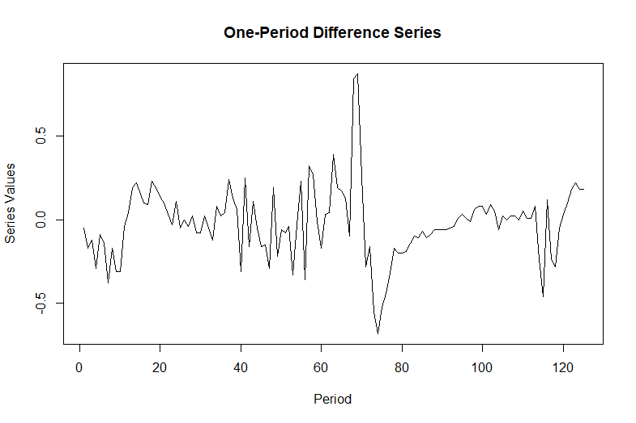

Paste the **one-period difference** series chart here

CREDIT CARD

DELINQUENCIES

**ACF AND PACF FOR ONE_PERIOD DIFFERENCED SERIES**

**ADF TEST FOR ONE-PERIOD DIFFERENCED SERIES**

The p-value for the ADF test is very low. We can reject the null hypothesis that the series is non-stationary at conventional levels.

Given the zig-zag shape (with negative autocorrelations between consecutive terms), the series is likely stationary.

The ACF graph shows a quickly declining autocorrelation, which is consistent with the ADF test as stationary. There are some spikes in the ACF, although barely significant.

There are several spikes in the PACF graphs, some spikes are even in large lags, so it is necessary to try some larger p in the ARIMA model.

**ONE-PERIOD DIFFERENCE SERIES PLOT**

The first differenced series illustrates a constant mean of 0 and oscillates around 0, so there seems to be a mean reverting process. Also, the zig-zag pattern indicates that lagged terms may have negative autocorrelations.

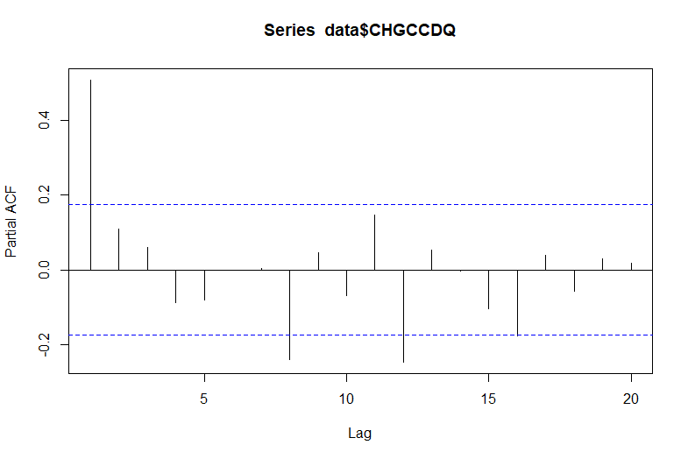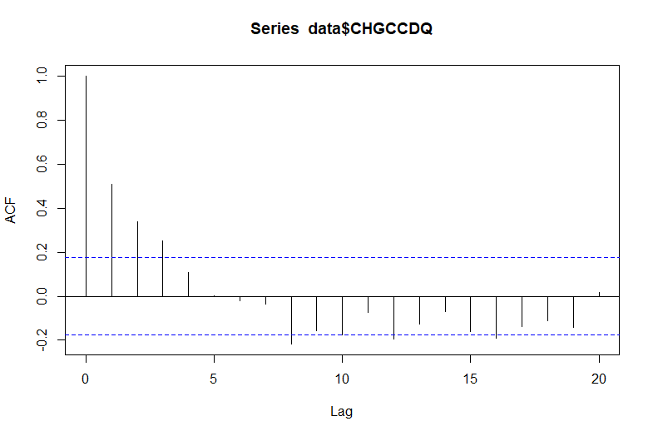

In this and the next box paste the **ACF and PACF** for the **one-period difference** series

Paste the **ADF** test outputs for the **one-period** series here

The time series seems to have a constant mean of 0, then it may be an either stationary or random walk. The graph has a zig-zag shape, indicating that there may be negative autocorrelation between lagged terms (not fully random), which may correspond to the autocorrelation spikes.

Although there are a few spikes in the ACF and PACF graphs, they are barely significant and not showing strong seasonal components.

**OTHER OBSERVATIONS**

**CREDIT CARD DELINQUENCY SERIES, HOLT’S**

**FORECAST OUTPUT**

CREDIT CARD DELINQUENCY SERIES,

HOLT’S

EXPONENTIAL

SMOOTHING

To have Holt’s exponential smoothing, replace the original value with the credit card delinquency, format other formula cells to match the series size, then forecast for 12 periods with the original weight and the last fitted level incremented by the last trend (assuming the trend for each forecast period is the same).

However, we found out that the fitted graph was inaccurate, and the final forecast did not catch the trend. So using the solver to find the optimized weight and forecast again. We got a nicely fitted graph that catches the final trend.

Optimized: α = 0.873, β=0.383

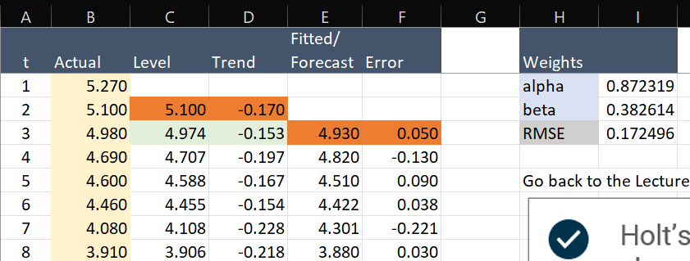

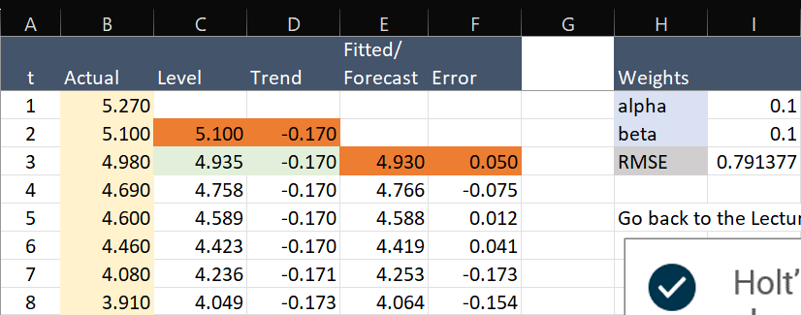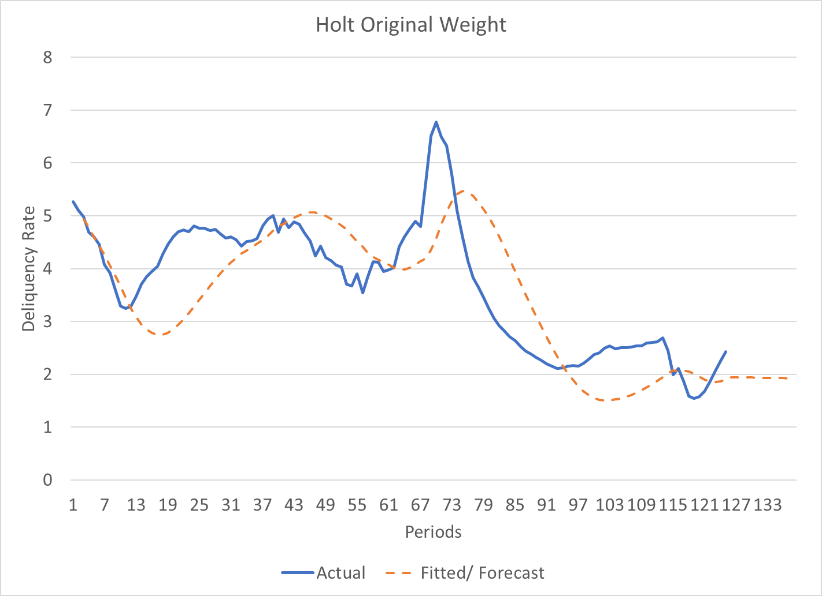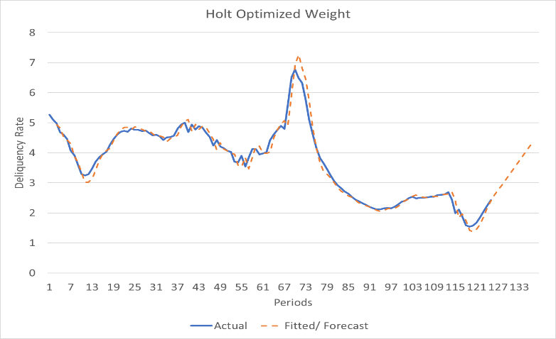

With the original weight, the fitted barely catches the graph's general quantity, shape, and movement. However, there are many forecast misses. For instance, the fitted curve cannot recognize changes in patterns timely (harder for the fitted curve to change with low weights). The forecast curve likely catches the trend incorrectly, either.

However, the graph with optimized weights has a nicely fitted curve. With higher weights, it can recognize changes in patterns more quickly and almost always fit the actual value closely. It also more likely catches the final trend, which is the upward trend during the last periods is more reasonable given the overall pattern of the graph.

Therefore, the optimized weight is much better for this series, and the forecast is quite convincing.

**COMPARISON OF FORECASTS WITH DIFFERENT WEIGHTS**

Paste a clip of the **Holt spreadsheet** based on the optimized weights

Paste a clip of the **Holt forecast chart** based on the optimized weights

Paste a clip of the **Holt forecast chart** based on the original weights

Paste a clip of the **Holt spreadsheet** based on the original weights

**CREDIT CARD DELINQUENCY SERIES, ARIMA**

**FORECAST OUTPUT**

There is a spike at the 8th lag in the PACF graph of the differenced series, so I take p = 8 as the AR lag to build the model. Although there are some considerable residuals (mostly at extreme values), none have significant correlations. In general, the fitted value still captured the pattern of the actual values.

The forecast is graphed in Excel with the forecasted value given by R. Since the R algorithm outputs the change of delinquency, the forecast is a smooth continuation based on the change from the actual value.

CREDIT CARD DELINQUENCY SERIES,

ARIMA

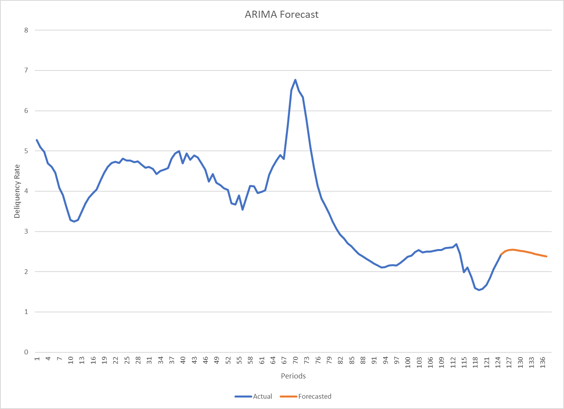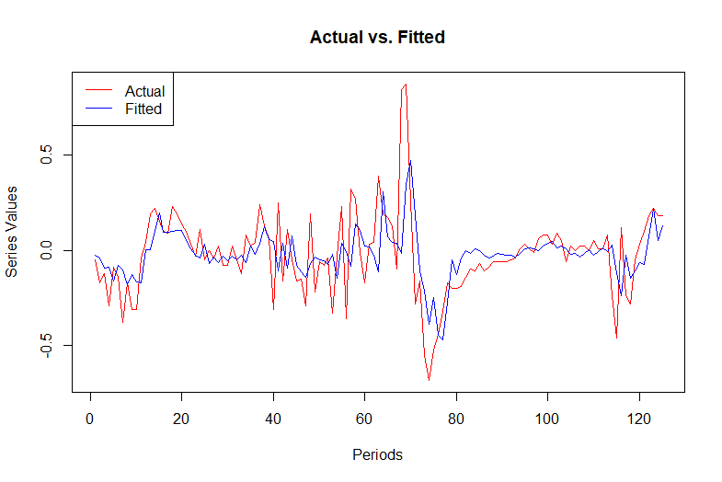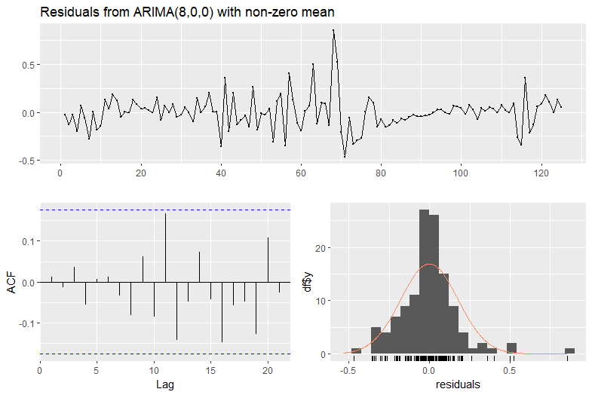

Paste **Ljung-Box test results for the ARIMA residuals**, produced on the left side screen in R, at the same time the residual diagnostics graphics is produced

Paste **ARIMA residuals diagnostic chart**, with the three small visuals

Paste the **Excel chart** showing the actual series with the **ARIMA forecast**

Paste the **ARIMA actual vs. fitted** chart

**FORECAST OBSERVATIONS**

Residuals are mostly normally distributed around 0, which is ideal for ARIMA. However, we may still see some sharp zig-zag patterns in the residual graph, especially from period 40-70, indicating that there may be still negative autocorrelations.

The ACF graph confirms that. Although there are no significant spikes, most autocorrelations during that interval are negative and close to be significant. The Ljung-Box test is needed for further identification.

**STATEMENT ABOUT MODEL’S FINAL RESIDUALS**

The Ljung-Box test has some evidence that the final residual of ARIMA may or may not be white noise as we can reject the null hypothesis at the 10% level.

The zig-zag shape of residual ACF may suggest that the residuals may still not be fully random, and there may still be some (negative) autocorrelation not captured.

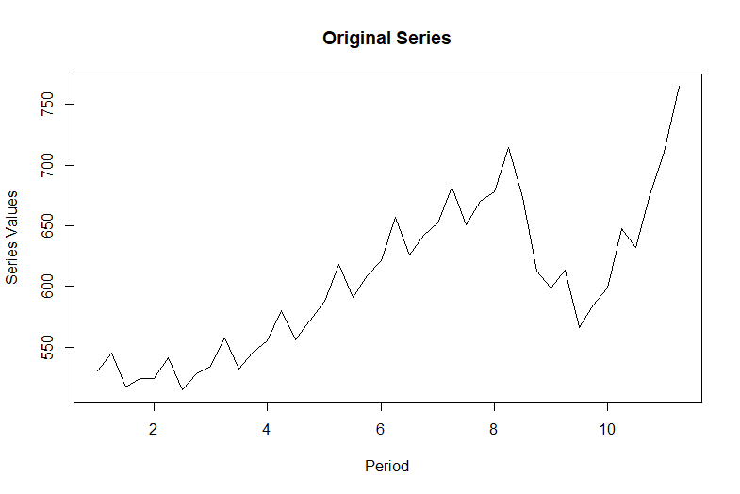

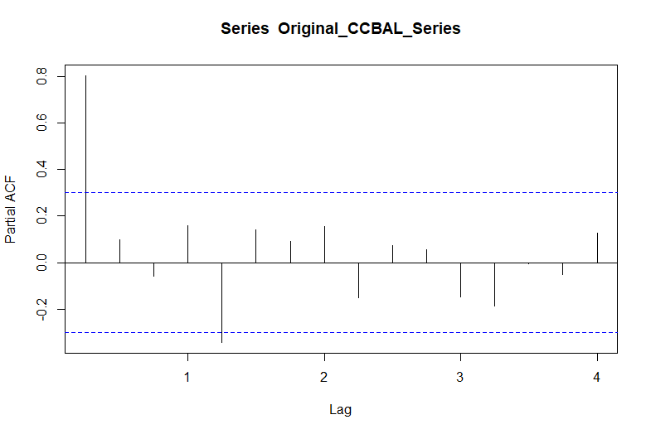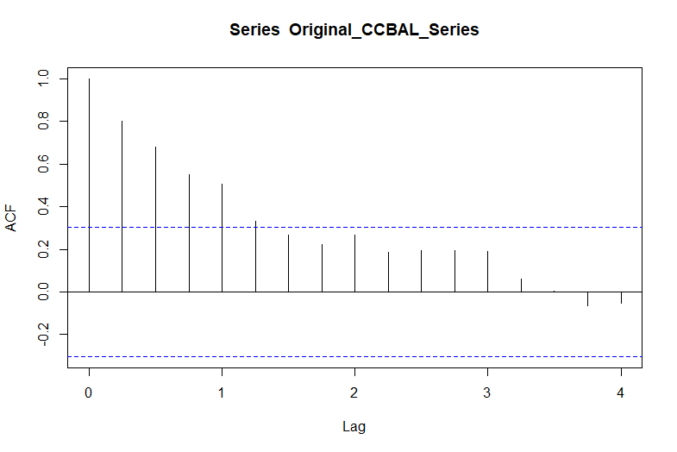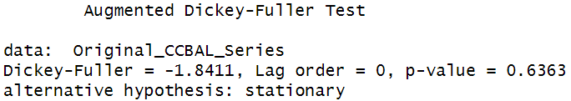

In this and the next box paste the **ACF and PACF** for the **level** series

Paste the **ADF** test results for the **level** series here

Paste the **level** series chart here

The decomposition of the level series confirmed that there is a positive trend and a considerable seasonal component.

The PACF does not have such corresponding spikes, which is not consistent with other outputs of the series. However, as other output suggested, it is still necessary to consider the seasonal components when building the forecast models.

**OTHER OBSERVATIONS**

The ACF graph shows a gradual declining autocorrelations, which is consistent with the ADF test as non-stationary. However, the ACF graph shows some wave shapes at certain seasonal lags that may be due to seasonal autocorrelations.

The PACF graph shows almost no significant direct autocorrelations with almost no spikes, so variables with larger lags are hard to predict based on partial autocorrelations.

CREDIT CARD

BALANCES

The pattern of the level series is not very smooth, and there are still many zig-zags. These zig-zags look repeated, so there may be considerable seasonal components.

However, the level series graph also show that there is no constant mean, and there is a positive trend over periods.

**LEVEL SERIES PLOT**

**ADF TEST FOR LEVEL SERIES**

The p-value for the ADF test is very high, far from the rejection range. We cannot reject the null hypothesis that the series is non-stationary.

The series is likely a random walk.

**ACF AND PACF**

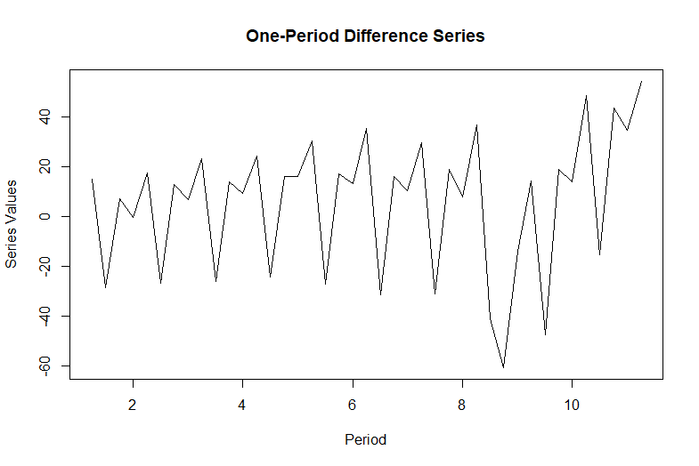

Paste the **one-period difference** series chart here

CREDIT CARD

BALANCES

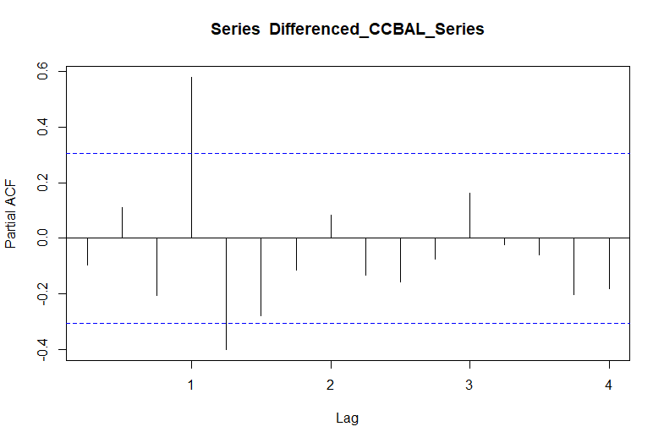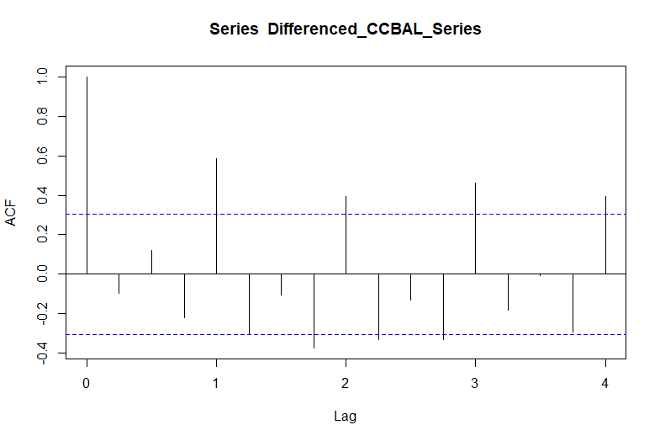

In this and the next box paste the **ACF and PACF** for the **one-period difference** series

Paste the **ADF** test results for the **one-period difference** series here

As the ADF test result shows, differencing cannot make the series stationary. The ACF has wavey autocorrelation patterns at seasonal lags. Irregular partial autocorrelations beyond the first year illustrate that future seasonal values are still hard to predict, and the series may still be a random walk and unpredictable.

**OTHER OBSERVATIONS**

The ACF graph shows a wavey shape at seasonal lags and repeated patterns, consistent with the ADF test result (not seasonally stationary).

The PACF graph also has some spikes, not only at seasonal lags but also around them. Those spikes also indicate the need for seasonal differencing to become stationary.

**ACF AND PACF FOR ONE_PERIOD DIFFERENCED SERIES**

**ADF TEST FOR ONE-PERIOD DIFFERENCED SERIES**

The p-value for the ADF test is very high, far from the rejection. We cannot reject the null hypothesis that the series is non-stationary.

The series is likely a random walk. However, given the seasonal component, it is necessary to take seasonal difference and test again.

**ONE-PERIOD DIFFERENCE SERIES PLOT**

After differencing, the seasonal component is more evident because most patterns look repeated. The graph also has sharp zig-zag shapes, as expected.

Although the pattern looks stationary, the repeated behavior may require more tests or processes to identify.

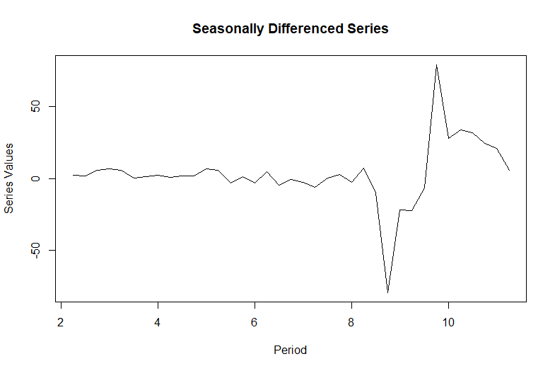

Paste the **seasonally differenced** series chart here

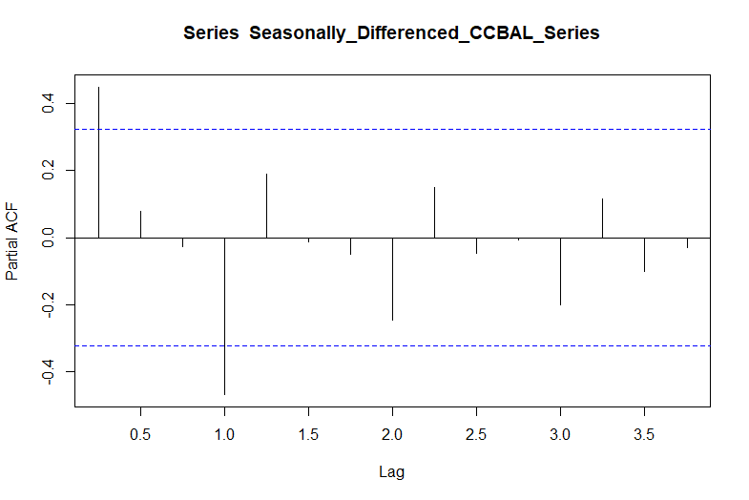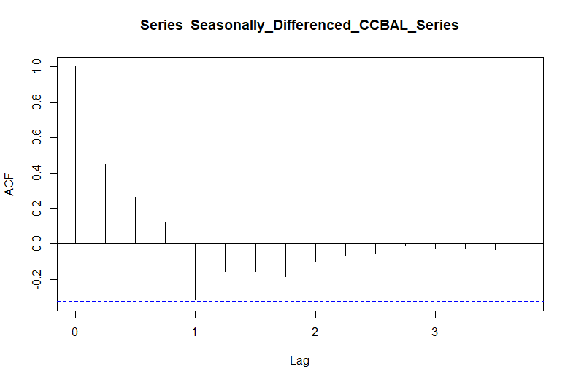

In this and the next box paste the **ACF and PACF** for the **seasonally differenced** series

Paste the **ADF** test results for the **seasonally differenced** series here

The p-value of the ADF test is moderately small: we can reject the null hypothesis at the 10% and 5% levels but not the 1% level. Therefore, the series tends to be stationary but not very strong, and the PACF graph also illustrates weak autocorrelations.

After seasonal differencing, the positive seasonal autocorrelations are eliminated, but the negative seasonal correlations are still noteworthy and need investigation.

**OTHER OBSERVATIONS**

The ACF graph shows a quickly declining autocorrelation without spikes, which is consistent with the ADF test as stationary.

The PACF graph shows a repeated pattern each year after seasonal differencing. It has some seasonal spikes, but most are insignificant, so we may not need a large p in our SARIMA model.

CREDIT CARD

BALANCES

**ACF AND PACF FOR SEASONALLY DIFFERENCED SERIES**

**ADF TEST FOR SEASONALLY DIFFERENCED SERIES**

The p-value for the ADF test is low. We can reject the null hypothesis that the series is non-stationary at the 10% and 5% levels.

Since we have differenced the series seasonally, it is likely stationary now, so some non-stationary characteristics are likely seasonal.

**SEASONALLY DIFFERENCED SERIES PLOT**

After differencing seasonally, the seasonal component is eliminated, so the graph looks steady without an explicit linear trend. The shock between periods 8 and 10 still exists from the level series, so it is likely the random shock that cannot be eliminated from seasonal differencing.

**CREDIT CARD BALANCES SERIES, HOLT-WINTERS**

**FORECAST OUTPUT**

Like Holt’s exponential smoothing, we replace the original series with the credit card balance series, format the formulas to match the size, and then forecast 12 periods. However, with seasonal data, it is noteworthy that seasonal forecasting requires different seasonal multipliers for different seasons (so we use the last four seasonal components iteratively instead of a single one).

Then we use both the original and optimized weights to test the fitness.

Optimized: α = 0.959, β=0.574, γ=1

CREDIT CARD   
BALANCES SERIES,

HOLT-WINTERS

EXPONENTIAL

SMOOTHING

Paste a clip of the **Holt-Winters spreadsheet** based on the optimized weights

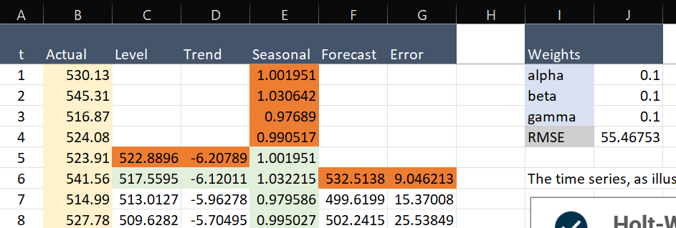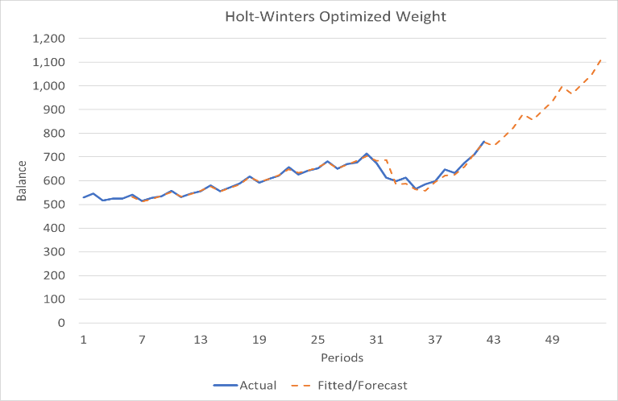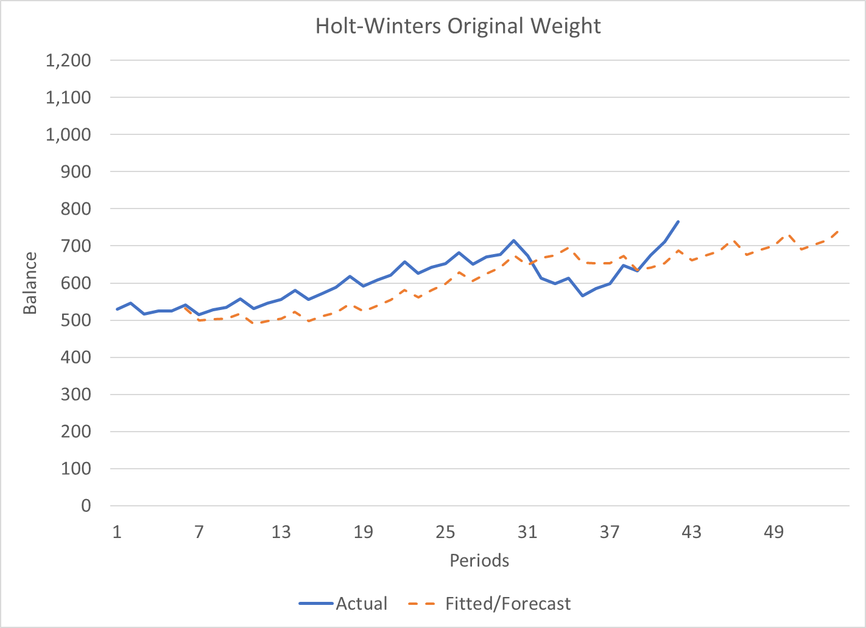

Paste a clip of the **Holt-Winters forecast chart** based on the optimized weights

Paste a clip of the **Holt-Winters spreadsheet** based on the original weights

Paste a clip of the **Holt-Winters forecast chart** based on the original weights

Like Holt’s exponential smoothing, the original weight does not produce a closely fitted curve. Due to its low weights, it still does not seem to catch the series’ trend or the shock.

However, the forecast produced by the optimized also revealed some unique weaknesses. The curve still fits nicely due to its high weight. However, high weights also indicate that the forecast is primarily driven by short-term observed values (rather than long-term fitted levels and trends) to recognize pattern changes quickly. However, the graph shows that such a forecast is not immune to random shocks. The forecast treats the (likely) shock as the trend and forecasts based on such a wrong trend. Ironically, the original weight’s forecasted trend may be more accurate than the optimized weights’s.

**COMPARISON OF FORECASTS WITH DIFFERENT WEIGHTS**

**CREDIT CARD BALANCES SERIES, SEASONAL ARIMA**

**FORECAST OUTPUT**

The SARIMA model is quite like the ARIMA but works with a seasonally differenced stationary series, which we have for credit card balance. We choose 1 for both AR and MA lags because we have spikes here at ACF and PACF but none further.

The fitted curve and forecast are ideal for SARIMA. The curve fits closely with the actual value, and the forecast captures the trend and seasonality well.

CREDIT CARD BALANCES,

SEASONAL ARIMA (SARIMA)

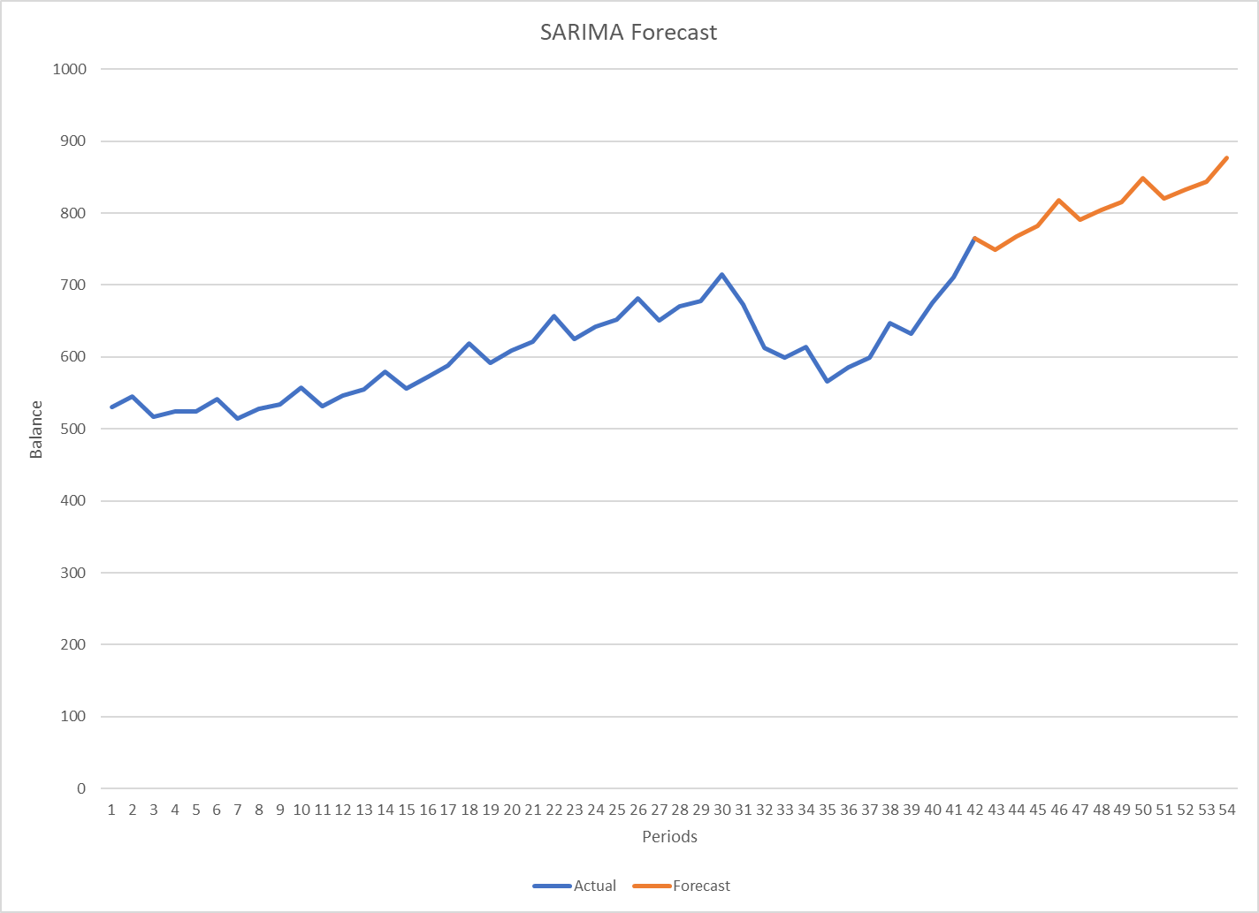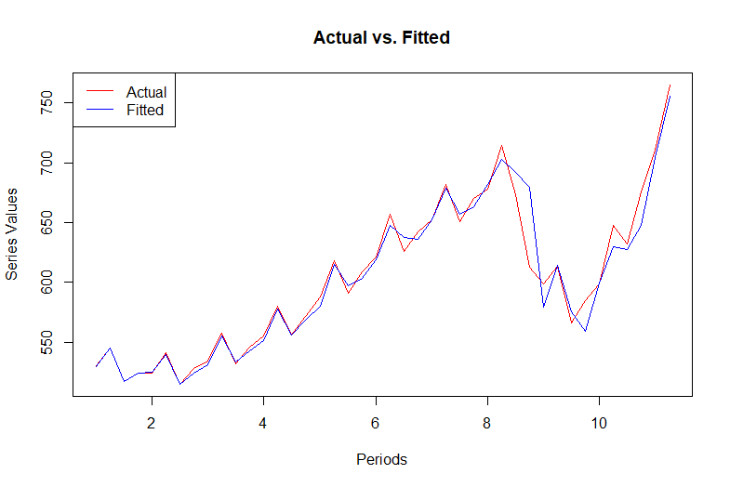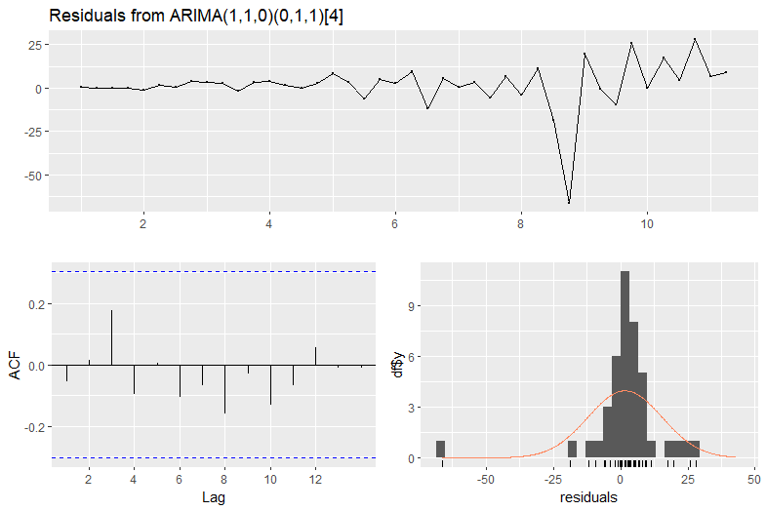

The p-value of the Ljung-Box test is far from the rejection range, so we have strong evidence that the final residuals are white noise. The SARIMA process captures the autocorrelation. It is also consistent with the graph and residual diagnostic.

Paste **Ljung-Box test results for the SARIMA residuals**, produced on the left side screen in R, at the same time the residual diagnostics graphics is produced

Paste the **Excel chart** showing the actual series with the **SARIMA forecast**

Paste **SARIMA residuals diagnostic chart**, with the three small visuals

Paste the **SARIMA actual vs. fitted** chart

The ACF graph of residuals is ideal for SARIMA. It has no spikes, and most autocorrelations are far from being significant. Residuals are also mostly normally distributed around 0. Although there is an outlier residual, given the low autocorrelation, it is likely a random shock, which is acceptable for SARIMA.

The residual diagnostic is consistent with a nicely fit graph and shows a strong SARIMA forecast.

**FORECAST OBSERVATIONS**

**STATEMENT ABOUT MODEL’S FINAL RESIDUALS**

Exponential smoothing only cares about the series’ pattern, so it has no requirements for autocorrelation structures. Therefore, ARIMA/SARIMA may fail to produce a predictive forecast for series with complicated autocorrelation structures like credit card delinquency. But with exponential smoothing, we can always try to find a set of parameters associated with a nicely fitted curve and forecast based on that. Moreover, exponential smoothing is just simple arithmetic. It may even be done by hand, but it is almost impractical for ARIMA/SARIMA.

However, overly relying on repeated patterns is also the weakness of exponential smoothing. For instance, exponential smoothing either unrecognizes the change in trend or forecasts based on random shocks. In contrast, ARIMA/SARIMA does not rely on pattern change and is more immune to pattern changes and random shocks (with a stable autocorrelation structure), which is what exponential smoothing cannot offer.

I recommend Holt’s exponential smoothing with the optimized weight for the credit card delinquency series. With the optimized weight, the forecast model fits closely with the actual value, and the forecasted pattern also have a reasonable trend given the structure and pattern of the graph. The ARIMA fitted curve does not fit as nicely as the former, and there is even doubt that whether the residuals are white noise given the p-value.

However, SARIMA would be better for credit card balance, both weights used in Holt-Winters have some unique weaknesses in terms of forecast accuracy. In contrast, SARIMA would produce a nicely fitted curve by modeling all autocorrelations (especially seasonal autocorrelations), and the forecast is reasonable in both matching the trend and showing the matching seasonal pattern.

The parameters are the most critical factor for exponential smoothing, directly determining the forecasted pattern. The process is simple and flexible, with everything done with different weights. However, each set of unique weights has weaknesses, as the credit card balance shows. Due to small sample sizes, we usually need large weights to follow the observed values closely, which is not immune to random shocks. We may not need such large weights to forecast correctly if we have a larger sample size. It just depends on optimizing weights.

For ARIMA/SARIMA, it is essential to have more comparison metrics like the CLS or ML to select models. For instance, both ARIMA models of credit card delinquency are not ideal, and it is also somewhat hard to choose from. More comparison metrics like RMSE from CLS or ALC from ML may better distinguish these models.

**What does exponential smoothing offer that ARIMA/SARIMA do not offer, and what do ARIMA/SARIMA offer that exponential smoothing does not offer? Explain, drawing from your assignment analysis.**

**If you had to recommend to your colleagues what method to use between exponential smoothing or ARIMA (or SARIMA in the seasonal case) for the above forecasts, which one would you select? Why?**

**Given what you did to produce the forecasts, what do you think would be useful, in addition to the data and assumptions you used, to improve the quality of the exponential smoothing and ARIMA/SARIMA forecasts?**

**METHODOLOGIES**

DISCUSSION

Credit card delinquency rates have dropped to a historically low level of 1.54% in Q3 2021. There are some signs of bouncing back, as the trend and our forecast show, but the level is still low compared to the historical average. While it is possible due to the inflation in 2022, we need more evidence to support that. For instance, historical data show that economic cycles are not so correlated with delinquency rates, and there are different delinquency rate patterns during different recessions. The delinquency rate is likely not associated with credit card balances, either. As the credit card balance increases, the delinquency rate even drops. However, it is noteworthy that credit card APR has increased dramatically in recent years (bypassing 20%), which may be the reason for dropping delinquency rates. However, holding that constant, I still forecast that delinquency rates positively correlate with credit card balances, and they tend to be higher with a bad economy.

I still need more data, maybe the delinquency rates holding APR constant, or I can learn more about borrowers’ behaviors. Delinquency is still different from default, so learning if people just forget to pay, wait to pay, or don’t have money to pay is essential to establish a comprehensive plan.

**Assume you are the Chief Credit Officer for a U.S. bank with a significant share of the country’s credit card business. Before answering this question, do high-level background research on the U.S. bank industry’s credit card business (trends, risk, expectations, etc.). Then, based on the knowledge you acquired, assess the direction and magnitude of the forecasts you produced. First, discuss whether you would adjust the delinquency and lending projections (lending is positively correlated with the balances) based on your perspective as a credit officer. Second, list information you feel you would need before deciding whether you to restrict, maintain, or increase the banks’ lending activities (lending affects the balances).**

**In the case of the ARIMA forecast, there were two choices, one with one AR term and another with eight AR terms. Does the choice of AR parameter make a meaningful difference in the model fit or forecast? Based on the results, which one would you choose? Why?**

**Also, in the case of the ARIMA forecast, the R code generates a table with the forecast and their 95% confidence interval (CI). A colleague asks you to explain what this CI means and why it seems so wide. Explain, in your own words, based on the results.**

The 95% confidence interval is an interval that captures 95% area of the distribution centered around the forecast value. In other words, if the forecast model is correct, we are 95% confident that the interval will capture the actual value (capture 95% of actual values for repeated forecasts). The size is proportional to the standard error of the forecast distribution, so a large standard error can lead to a wide CI needed to include 95% of the distribution.

The CI can be an essential indicator to forecast accuracy. If the CIs cannot capture the actual value by their corresponding confidence levels, that’s a warning sign for incorrect models.

No, the two choices of AR lags produce similar results regarding fitted graphs, residual distributions, and p-values of the Ljung-Box test. Therefore, one AR lag tends to be better in the principle of Parsimony. However, I still chose the 8th lag because I noticed that the ACF of the 1st lag ARIMA residual has some significant spikes (although they have similar p-values). Recall that we also have a spike at the 8th lag of the differenced series’s PACF, I think it is necessary to model this part of partial autocorrelation in the ARIMA model to eliminate such lags to make sure the result is truly random.

**FORECAST RESULTS AND APPLICATION**

DISCUSSION

CONCLUSION

Both univariate forecast techniques are powerful but also have their respective weaknesses. Exponential smoothing is simple and flexible without autocorrelation structure requirements. Still, it relies on repeated patterns and is not immune to pattern shifts like changes in trend (for low weights) or random shocks (for high weights). In contrast, ARIMA/SARIMA does not rely on patterns and is more immune to pattern changes. However, it requires a modellable autocorrelation structure (stationary) and has more complicated algorithms to ensure a successful forecast (white noise residual). In practice, different time series may have different preferences over algorithms, so we should try both to see which one can produce a more reasonable forecast.

Moreover, seasonal differencing and SARIMA are potent techniques. For seasonal data, simple differencing may

It may not be enough for stationary, but differencing by season and conducting SARIMA can lead to a more accurate forecast.